
Computing Curriculum: Vocabulary Progression

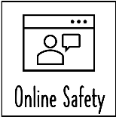
V

EYFS



We are Safe Researchers
Safe search, Search engine, Filter
We are Photographers
Camera roll, Crop, Filter, Adjust
We are Astronauts
Algorithm, Bug, Debug, Repetition, Sprite

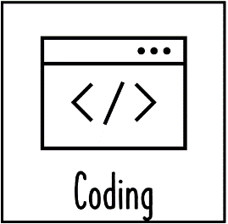

KS1
Year A

KS1
Year B

LKS2
Year A

LKS2
Year B

UKS2
Year A

UKS2
Year B

We are Publishers
Audio, Filter, Safe search, Search engine, Multimedia, eBook
We are Rhythmic
Audio, Microphone, Speaker, Track
We are Game Testers
Algorithm, Bug, Debug, Input, Output, Repetition, Sprite

We are Bloggers
Internet, URL, Web server, Blog

We Are Who we Are
Personal information, Narration, Storage, Comments

We are Programmers
Code, Decomposition, Event, Program, Storyboard, Variable

We are Bloggers

Internet, URL, Web server, Blog

We are Musicians
Beat Sequencer, Live Loops, MIDI, Compose

We are Software Developers
Code, Debug, Repeat loop, Event, Program, Varibale

We are Web Developers
Social media, Web Browser, World Wide Web, Content
We are Architects
Computer aided Design (CAD), Render, Aesthetic, Decomposition

We are Game Developers
Variables, Code, Logical Reasoning, Program

We are Connected
Blog, Social media, Web Browser, World Wide Web

We are Advertisers
Rushes, Creative commons, Export, Rough cut, Final cu
We are Toy Makers
Controller, LED, Iterative Development, Logical Reasoning, Decomposition

